Contents

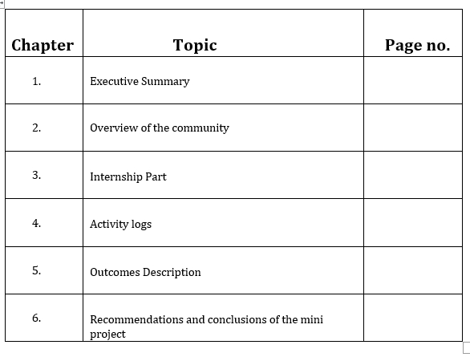

### CHAPTER 1: EXECUTIVE SUMMARY

The internship report shall have only a one-page executive summary. It shall include five or more Learning Objectives and Outcomes achieved, a brief description of the sector of business and intern organization and summary of all the activities done by the intern during the period.

* **HTML**provides the *basic structure* of sites, which is enhanced and modified by other technologies like CSS and JavaScript.
* **CSS** is used to control presentation, formatting, and layout.

### JavaScript is used to control the behavior of different elements

**OBJECTIVES:**

1. Introduction to hyugro solutions, web technologies and Knowing about existing tools that are required for the web development.

2. Introduction to HTML (Hyper Text Markup Language) basics, tags, ect..

3. Brief explanation about HTML links, images, ect. and creation of webpage.

4. Introduction to CSS (Cascading Style Sheets) basic topics and styles.

5. Explanation about CSS important topics and webpage development using html and css.

6. Development of some webpages and introduction to JavaScript.

7. Basic concepts, arrays, ect.. of JavaScript and overview of above topics.

8. Implementation of project using html, CSS, JavaScript.

**Outcomes:**

1. Successfully finished learning html
2. Implemented a webpage using html
3. Successfully finished learning css
4. Implemented a responsive web page using css
5. Understood javascript basics
6. Done with the linking of html, css and javascript together and developing a web page

### CHAPTER 2: OVERVIEW OF THE ORGANIZATION

##### **Suggestive contents:**

* 1. Introduction of the Organization
  2. Vision, Mission, and Values of the Organization
  3. Policy of the Organization, in relation to the intern role
  4. Organizational Structure
  5. Roles and responsibilities of the employees in which the intern is placed.

### INTRODUCTION OF THE ORGANIZATION:

Hyugro Solutions Private Limited is a Private incorporated on 08 October 2020. It is classified as Non-govt company and is registered at Registrar of Companies, Vijayawada. Its authorized share capital is Rs. 1,000,000 and its paid up capital is Rs. 100,000. It is inolved in other computer related activities [for example maintenance of websites of other firms/ creation of multimedia presentations for other firms etc.] . 2 Directors are associated with the organization. Directors of Hyugro Solutions Private Limited are Hyugro Phani Dev Golla and Jyothi Doddi.

Hyugro Solutions Private Limited's Corporate Identification Number is (CIN) U72900AP2020PTC115990 and its registration number is 115990.Its Email address is [hyugrosolutions2020@gmail.com](mailto:hyugrosolutions2020@gmail.com) and its registered address is Villa 7, NSR Villas Bypass Road Mangalagiri Guntur AP 522503 IN .Hyugro Solutions Private Limited is a 2 years 1 month old Private Company incorporated on 08 Oct 2020. Its registered office is in Guntur, Andhra Pradesh, India.



### COMPANY INFORMATION

Company Name - HYUGRO SOLUTIONS PRIVATE LIMITED CIN No - U72900AP2020PTC115990

Date of Incorporation - 2020-10-08 State - Andhra Pradesh

Class - Private

Category - Company limited by Shares Sub Category - Non-govt company

Activity Code - NA

Activity Description - Computer and related activities

**FINANCIAL INFORMATION**

Authorised Capital Paid Capital - Rs. 1000000.0

Paid Capital - Rs. 100000.0

Latest Annual Report - N/A

Latest Balance Sheet - N/A



##### **VISION, MISSION AND VALUES OF THE ORGANIZATION**:

Being professional web development, mobile application and digital marketing company. Our mission is to provide customer-centric, result-oriented, cost-competitive innovative & functional IT Solutions to our valuable global clients. We stick to the following principles in delivering our

**Mission:**

Being professional web development, mobile application and digital marketing company. Our mission is to provide customer-centric, result-oriented, cost-competitive innovative & functional IT Solutions to our valuable global clients. We stick to the following principles in delivering our mission:

* We understand needs and requirements of our customer and make technology to resolve the needs
* We believe to explore new opportunities that maximizes the business value, consistent growth and sustainability
* Empower our clients to respond faster and more intuitively to changing market dynamics
* Enable them to become more agile and competitive through leveraging new technologies
* Help our clients to bring great products to market in less time and at less cost
* Collaborate with our clients in their continued success.

### Vision:

Our vision is to be the largest global mobile/web development company. Focused on constant innovation as our key for achieving the ultimate goal of success and emerge as globally recognized company by providing the superior quality services and solutions. We stick to the following principles in delivering our vision: We believes in exploring new opportunities that maximizes the business value, consistent growth and sustainability using our core competencies. Meeting expectations of our customers, employees, and partners. Operate globally and bring the benefits of IT to improve the quality of the products and services of our clients. Be a vibrant organization where openness, trust, teamwork, simplicity, and innovation are valued and promoted. We values integrity, commitment, excellence, teamwork, transparency, and satisfaction for our clients and ourselves. Globally recognized for providing quality Services to its customers worldwide while adhering to our core values

##### **POLICY OF THE ORGANIZATION:**

Employing interns. It highlights the business case for offering internships, including the benefits for both the employer and the intern.

The business case for creating an internship program is strong:

1. Employers of interns obtain relatively inexpensive labor at the cost of giving training to the interns. Interns typically work for a short period of time without benefits.
2. Employers acquire ready access to a pool of potential hires.
3. Employers obtain much better knowledge of prospective employees' knowledge, skills and abilities by watching the interns in action than by simply reading resumes or job applications.
4. Employers can gain brand recognition and improved community relationships through internship programs, as well as improve employee morale.
5. An employer can attract positive attention from the news media reporting on the start and finish of the internship program for high school or college students, introducing the interns and discussing how their nascent talents could lead to employment at the organization in the future.
6. Often, interns are related to current employees. The possibility that a relative could land an internship with an organization can boost its employees' productivity and job satisfaction.
7. An internship program can be a key component of an organization's diversity

##### **ORGANIZATIONAL STRUCTURE:**

We are the team of 6:

1. Project manager and project architect.
2. Front-end developer(2).
3. Back-end Developer(2).
4. Content writer.

##### **Roles and responsibilities of the employees in which the intern is placed.**

During the period of Internship Program with us Students has been exposed to various concepts like Frontend & Backend Web Application Development (HTML, CSS, JavaScript, React.js, Node.js, Mysql etc.During this period Students has contribution in "Ecommerce Web Application Development" and core work areas involved Performing Vulnerability Assessment on Web Applications.

### CHAPTER 3: INTERNSHIP PART

*Description of the Activities/Responsibilities in the Intern Organization during Internship, which shall include - details of working conditions, weekly work schedule, equipment used, and tasks performed. This part could end by reflecting on what kind of skills the intern acquired.*

Soft skills are as important as hard skills. Soft skills are all about our ability to relate to people and building mutually-beneficial relationships. Examples are emotional intelligence, motivation, people-skills, listening, and excellent communication. Soft skills are key to navigating our work environment and can even contribute to job progression. Word of the wise, don’t underestimate them. In the beginning of my internship, I have spent my time simply trying to learn how the company works. I have shadow an employee to get an understanding of their role. Job shadowing has become the norm recently. As the name suggests, the practice involves “shadowing” someone as they perform their daily duties, observing their activities, and learning what the role entails via indirect experience. This is an especially popular practice in hands-on fields like engineering and healthcare. As time goes by, expect to shoulder an increasing amount of responsibility. Initially, they’ll gauge my current skill set and reliability with my initial workload. As I haved proved myself to my colleagues and bosses, I’ll be entrusted with more crucial tasks. The better I perform, the more the responsibilities I’ll be given. This is an excellent opportunity to showcase our abilities to employer. It can also help contribute to receiving a full- time role afterwards. Employers prefer quality over quantity – don’t afraid to ask for help if you need it. Interns who can display that they can handle additional work and keep with tight deadlines will be more likely to impress the boss

Mentors act as anchor roles for interns. If you find a good one, you can follow in their footsteps and build a successful career just like your mentor. Interning is hard. Finding a peer support group who is going through all the ups and downs with you will make it much more enjoyable for everyone involved. Networking involves building relationships with my bosses, colleagues, and customers and clients. You’ll need the backing and support of people in places to build a successful career. Also, building good relationships with customers is always good for the organization. Interns who can build strong individual bonds with their coworkers and bosses become a part of the “family”. You’re much more likely to be offered a full-time role at the company down the road. I got a taste of what working in the industry full-time would be like. That’s the beauty of an internship I can always go into another field I would like. Email and Password Validation means the process of verifying the email address and the strength of the password the user has input. And, the password show hide means showing and hiding the password while clicking on the icon for security purposes. Actually when we put inaccurate data on the input field or directly click on the button then those errors appear with an error message. On the password field, on the right side, we can see the eye icon. When we click on the icon, it helps us to show the characters that we filled. The confirm password field will check the created password and the confirmed password is matching or not.

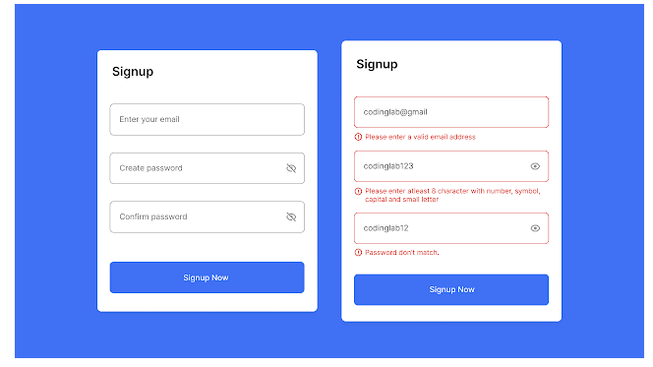

# **Weekly work schedule:**

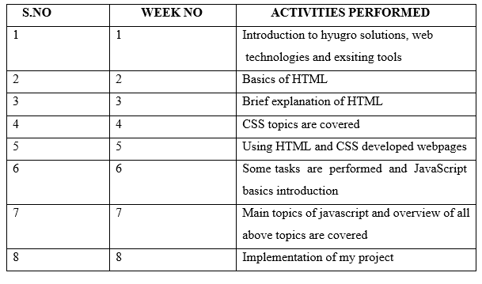

**REQUIREMENT ANALYSIS:**

## Hardware Requirements:

* 1. Monitor
  2. 8GB supported system
  3. OS:64 bit
  4. Windows 8-version

## Software Requirements:

1. HTML
2. CSS
3. JS
4. Visual Studio Code
5. Notepad++
6. Web browser

# Tasks Performed:

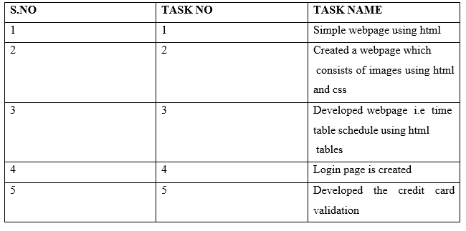

## CHAPTER 5: OUTCOMES DESCRIPTION

**Describe the work environment you have experienced** *(in terms of people interactions, facilities available and maintenance, clarity of job roles, protocols, procedures, processes, discipline, time management, harmonious relationships, socialization, mutual support and teamwork, motivation, space and ventilation, etc.)*

I have worked on designing of frontend web page development. I have worked in the organization through online. As a part of completion of my internship the organization has assigned a project in which I choose email id and password validation. No one loves email bounce backs, primarily when SDRs conduct cold email campaigns. According to a recent report by [Constant Contact](https://knowledgebase.constantcontact.com/articles/knowledgebase/5409-average-industry-rates), the average email bounce rate is 9.75%.But a good email bounce rate is less than 2%. Anything above 2% is considered critical.**In order to achieve this, you can use email verification techniques. Verification of email addresses is the process of ensuring that the emails are active and existent.**It cleans your email list by filtering the spammy and invalid addresses that help you securely proceed towards your email campaign. But many email professionals are unaware of how to verify email addresses.

**Why should we verify email addresses?**

Before jumping into the steps to verify the email addresses, let’s go through the quick benefits of email verification. This will help you understand the advantages of email verifications and its consequences.

**Advantages of email verification**

1. [Stay away from bounces](https://www.saleshandy.com/blog/verify-email-address/#stay-away-from-bounces)
2. Better sender reputation score & email deliverability
3. Getting better results from your email campaign (sequence)
4. Keeps your email lists fresh
5. [Reduce spam complaints](https://www.saleshandy.com/blog/verify-email-address/#reduce-spam-complaints)

**How to verify an email address before sending cold emails?**

There are multiple techniques to verify email addresses. Some of them require advanced knowledge of email technology. However, we have added some easy techniques to verify your email accounts in this section. We have also tried to provide simplified solutions to tackle the technical difficulties associated with it.

**7 best tactics to verify your email addresses**

[1. Check the email syntax](https://www.saleshandy.com/blog/verify-email-address/#one)  
[2. Ping the server](https://www.saleshandy.com/blog/verify-email-address/#two)  
[3. Send an email from a different account](https://www.saleshandy.com/blog/verify-email-address/#three)  
[4. DNS lookup](https://www.saleshandy.com/blog/verify-email-address/#four)  
[5. Perform an IP address lookup](https://www.saleshandy.com/blog/verify-email-address/#five)  
[6. Use an email verification tool](https://www.saleshandy.com/blog/verify-email-address/#six)  
[7. Verify your email list while sending cold emails](https://www.saleshandy.com/blog/verify-email-address/#seven)

**Describe the real time technical skills you have acquired (***in terms of the job-related skills and hands on experience)*

## **Frontend:**

It is the visible part of website or web application which is responsible for user experience. The user directly interacts with the frontend portion of the web application or website.

The part of a website that the user interacts with directly is termed the front end. It is also referred to as the ‘client side of the application. It includes everything that users experience directly: text colors and styles, images, graphs and tables, buttons, colors, and a navigation menu. HTML, CSS, and JavaScript are the languages used for Front End development.

## **Front end Languages**:

The frontend portion is built by using some languages which are discussed below:

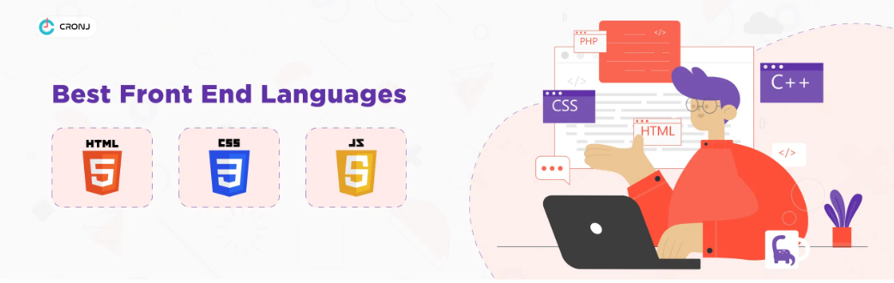

## [**HTML:**](https://www.geeksforgeeks.org/html-tutorials/)

HTML stands for Hyper Text Markup Language. It is used to design the front end portion of web pages using markup language. HTML is the combination of Hypertext and Markup language. Hypertext defines the link between the web pages. The markup language is used to define the text documentation within tag which defines the structure

of web pages

## **Features of HTML**:

It is easy to learn and easy to use. It is platform-independent.

Images, videos, and audio can be added to a web page. Hypertext can be added to the text.

It is a markup language.

## **Advantages:**

HTML is used to build websites. It is supported by all browsers.

It can be integrated with other languages like CSS, JavaScript, etc.

## **Disadvantages:**

HTML can only create static web pages. For dynamic web pages ,other languages have to be used.

A large amount of code has to be written to create a simple web page. The security feature is not good

**Css**

Cascading Style Sheets, fondly referred to as CSS, is a simply designed language intended to simplify the process of making web pages presentable. CSS allows you to apply styles to web pages. More importantly, CSS enables you to do this independent of the HTML that makes up each web page.There are three types of CSS which are given below:

**Inline:** Inline CSS contains the CSS property in the body section attached with the element known as inline CSS.

**Internal or Embedded:** The CSS ruleset should be within the HTML file in the head section i.e the CSS is embedded within the HTML file.

**External:** External CSS contains a separate CSS file that contains only style property with the help of tag attributes. HTML is used to define a structure of a web page whereas CSS is used to style the web pages by using different styling features. HTML consists of tags inside which text is enclosed and CSS consists of selectors and declaration blocks. CSS can be internal or external depending upon the requirement. We cannot use HTML inside a CSS sheet but we can use CSS inside an HTML document. CSS has comparatively higher backup and support than HTML.used to style the web pages by using different styling features. HTML consists of tags inside which text is enclosed and CSS consists of selectors and declaration blocks. CSS can be internal or external depending upon the requirement. We cannot use HTML inside a CSS sheet but we can use CSS inside an HTML document. CSS has comparatively higher backup and support than HTML.



**Why is CSS used in HTML?**

Solves a big problem , Saves a lot of time , Provide more attributes , Pages load faster , Easier Website maintenance , Multiple device compatibility , Base for web development , ect…

# JavaScript:

JavaScript is a famous scripting language used to create the magic on the sites to make the site interactive for the user. It is used to enhancing the functionality of a website to running cool games and web-based software.

JavaScript can be added to your html file in two ways:

**Internal JavaScript:** We can add JS code directly to our HTML file by writing the code inside the <script> tag. The <script> tag can either be placed inside the <head> or the <body> tag according to the requirement.

**External JavaScript File:** We can create a file with .js extension and paste the JS code inside it. After creating the file, add this file in <script src=”file_name.js”> tag inside <head> tag of the HTML file.

**Syntax:** It is the basic syntax to write code.

<script>

// JS Code

</script>

## Why JavaScript is used?

JavaScript is the most popular programming language for both client-side and server-side to make interactive web pages. It is mainly used to develop websites and web-based applications. **Creating Interactive Websites:** JavaScript is used to make the web pages dynamic and interactive. It means using JavaScript, we can change the web page content and styles dynamically.

**Building Applications:** JavaScript is used to make web and mobile applications. To build the web and mobile apps, we can use most popular JavaScript frameworks like – ReactJS, React Native, Node.js etc.

**Web Servers:** We can make robust server applications using JavaScript. To be precise we use JavaScript frameworks like Node.js and Express.js to build these servers.

**Game Development:** JavaScript can be used to design Browser games. In JavaScript, lots of game engines available that provide frameworks for building games.

**Describe the managerial skills you have acquired** (*in terms of planning, leadership, team work, behaviour, workmanship, productive use of time, weekly improvement in competencies, goal setting, decision making, performance analysis, etc.*

In this internship I have learned so many things. Not only the education knowledge but also learned how to communicate with others. Firstly I am not able to freely talk, mostly I use to be silent. But when I communicate with my mentor and team members I developed my communication skills. Also developed networking, soft skills, leadership qualities, ect.. I have developed competencies in the area of leadership, communication, problem-solving, teamwork, decision making. Leadership is the ability of an individual or a group of individuals to influence and guide followers or other members of an organization. Leadership is the art of motivating a group of people to act toward achieving a common goal. In a business setting, this can mean directing workers and colleagues with a strategy to meet the company's needs. I enjoy delegating tasks and taking the lead on projects, but I also like to stay involved and inspire my team by showing that I'm working hands-on to help them, too.

Listening to others is the first basic for everyone and I have that much of patience to listen everyone communication. The main quality of the leader ship is listen to everyone and I successfully completed my role in leadership. I really enjoy being a part of a team and I thrive when I'm able to effectively collaborate with others. I have served as both a team leader and a team contributor, so I'm extremely comfortable working in a team environment.I am very Adventurous, Courageous, Curious, Energetic, Enthusiastic in learning new things. I have developed the following things during my internship time.They are listed as follows Analytical Decision Making, Communication, Delegation, Adaptability, Teamwork, Creative Problem- Solving. The ability to motivate is another important skill in an organization. Motivation help bring forth a desired behavior or response from the employees or certain stakeholders.

**Describe how you could improve your communication skills** (*in terms of improvement in oral communication, written communication, conversational abilities, confidence levels while communicating, anxiety management, understanding others, getting understood by others, extempore speech, ability to articulate the key points, closing the conversation, maintaining niceties and protocols, greeting, thanking and appreciating others, etc.,)*

Communication is primarily about word choice. And when it comes to word choice, less is more. The key to powerful and persuasive communication—whether written or spoken—is clarity and, when possible, brevity. Effective communication is the process of exchanging ideas, thoughts, opinions, knowledge, and data so that the message is received and understood with clarity and purpose. When we communicate effectively, both the sender and receiver feel satisfied. Successful Communication is the conveying and understanding of a message from one person to another. Emphasis is placed on communication being clear by being transmitted strongly. communication to be effective, the meaning must be easily understood. An individual 's communicative success relies on factors that include speaking, reading, listening, and reasoning skills.

Through my work experience and education, I have developed strong communication skills, and I'm able to clearly convey points to different audiences. I'm also a good listener which aids in my ability to intimately understand a situation and prepare an appropriate response. Managing conflict is about empathy and understanding the other person’s perspective. Listening to what the other person says and reading their body language is key. I try to understand the situation from the other person’s point of view, come up with possible resolutions, and consult with them as to what will meet their needs. Communication is not only just about speaking but also encloses the followings: presentation, active listening, nonverbal communication, giving/taking feedback, and others. I am an empathic listener and persuasive speaker. I have Confident, articulate, and professional speaking abilities. I manage my anxiety through mindfulness, relaxation techniques, correct breathing techniques, dietary adjustments. an extemporaneous speech is actually a well-prepared speech that relies on research, clear organization, and practiced delivery. It is neither read nor memorized, so it is never delivered exactly the same way.

**Describe how could you could enhance your abilities in group discussions, participation in teams, contribution as a team member, leading a team/activity.**

I have the ability to compromise, show respect to others and listen to the needs of my teammates. While I can be a leader when necessary, I can also play an equal role on the team when the situation merits. I developed a team mentality as think we, not me. I am open to the ideas of my teammates. No one person has a monopoly on good ideas. Each idea can be built on until it becomes viable. In fact, the greater the contribution by all team members, the higher the chances of a successful implementation, as buy-in will be assured. I will respect others opinion, listen to their ideas. However, it’s not just on the pitch where being a good team player is important. Practically every job these days requires a certain level of teamwork and hiring managers will want to know that you work well with others.

Group discussions address gaps in students' knowledge. Allows me to discover and engage with a range of perspectives, ideas and backgrounds. Assist me in clarifying their attitudes to and ideas about the subject matter, as they test their own ideas and attitudes against those of others. It improves my thinking, listening and speaking skills. It also promotes my confidence level. It is an effective tool in problem solving, decision making and personality assessment. GD skills may ensure academic success, popularity. The main purpose of a group discussion is to measure group communication skills. Group communication skills deal with how a person in a group is able to communicate with other persons and influence his/her idea on others. All members of the group have a chance to speak, expressing their own ideas and feelings freely, and to pursue and finish out their thoughts. All members of the group can hear others' ideas and feelings stated openly. Efficiently delegating tasks is part of the job if you want to be an influential team leader. Good leaders should be able to prioritize the critical tasks and delegate the rest to the team. Dealing with conflicts on a routine basis is part of the team leadership role. Conflicts among team members will hamper productivity, affect the team bond, and foster a hostile environment. As great leader is also an accomplished mediator. When faced with conflict, an effective team leader doesn’t take sides. He tries to listen to both sides of the conversation and seeks to solve the issue

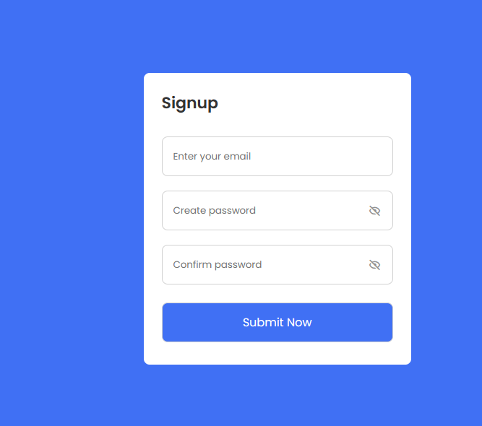

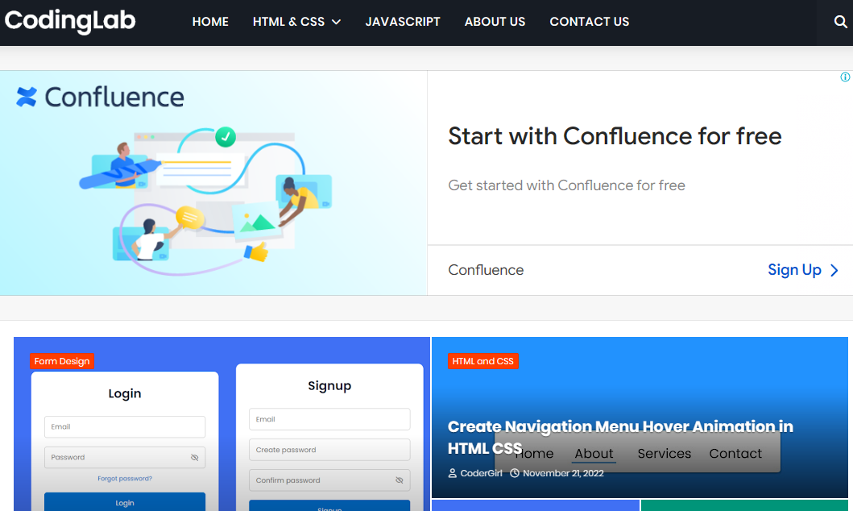

At first, there was a signup form with three empty input fields and a button. When I clicked on the button without filling in the required date, a red error message appeared. After that when I started to enter my valid data the error message disappeared. Also, we could show and hide passwords by clicking on the eye icon. The email required proper valid email formation and the create password field needs the combination of numbers, special symbols, capital, and small letter. Basically, we need not put eight characters by mixing all those characters.

 now you can create this type of form and validate email and password using HTML CSS and JavaScript, and also show and hide passwords while clicking on the eye icon with changing icon. If you are feeling complicated, I have provided all the HTML CSS and JavaScript code below.

**Describe the technological developments you have observed and relevant to the subject area of training** *(focus on digital technologies relevant to your job role)*

In my training I learnt about the frontend development and how to create web pages. My project is about **email and password validation**. Using HTML,CSS,JavaScript I developed the frontend of Netflix clone . The technology used for my project is shown as follows:

# HTML FILE:

Index.html file code:

<!DOCTYPE html>

<!-- Coding by CodingLab | www.codinglabweb.com-->

<html lang="en">

<head>

<meta charset="UTF-8" />

<meta http-equiv="X-UA-Compatible" content="IE=edge" />

<meta name="viewport" content="width=device-width, initial-scale=1.0" />

<title>Email and Password Validation</title>

<!-- CSS -->

<link rel="stylesheet" href="css/style.css" />

<!-- Boxicons CSS -->

<link

href="https://unpkg.com/boxicons@2.1.2/css/boxicons.min.css"

rel="stylesheet"

/>

</head>

<body>

<div class="container">

<header>Signup</header>

<form action="https://www.codinglabweb.com/">

<div class="field email-field">

<div class="input-field">

<input type="email" placeholder="Enter your email" class="email" />

</div>

<span class="error email-error">

<i class="bx bx-error-circle error-icon"></i>

<p class="error-text">Please enter a valid email</p>

</span>

</div>

<div class="field create-password">

<div class="input-field">

<input

type="password"

placeholder="Create password"

class="password"

/>

<i class="bx bx-hide show-hide"></i>

</div>

<span class="error password-error">

<i class="bx bx-error-circle error-icon"></i>

<p class="error-text">

Please enter atleast 8 charatcer with number, symbol, small and

capital letter.

</p>

</span>

</div>

<div class="field confirm-password">

<div class="input-field">

<input

type="password"

placeholder="Confirm password"

class="cPassword"

/>

<i class="bx bx-hide show-hide"></i>

</div>

<span class="error cPassword-error">

<i class="bx bx-error-circle error-icon"></i>

<p class="error-text">Password don't match</p>

</span>

</div>

<div class="input-field button">

<input type="submit" value="Submit Now" />

</div>

</form>

</div>

<!-- JavaScript -->

<script src="js/script.js"></script>

</body>

</html>

**CSS CODE:**

/* Google Fonts - Poppins */

@import url("https://fonts.googleapis.com/css2?family=Poppins:wght@300;400;500;600&display=swap");

* {

margin: 0;

padding: 0;

box-sizing: border-box;

font-family: "Poppins", sans-serif;

}

body {

min-height: 100vh;

display: flex;

align-items: center;

justify-content: center;

background: #4070f4;

}

.container {

position: relative;

max-width: 370px;

width: 100%;

padding: 25px;

border-radius: 8px;

background-color: #fff;

}

.container header {

font-size: 22px;

font-weight: 600;

color: #333;

}

.container form {

margin-top: 30px;

}

form .field {

margin-bottom: 20px;

}

form .input-field {

position: relative;

height: 55px;

width: 100%;

}

.input-field input {

height: 100%;

width: 100%;

outline: none;

border: none;

border-radius: 8px;

padding: 0 15px;

border: 1px solid #d1d1d1;

}

.invalid input {

border-color: #d93025;

}

.input-field .show-hide {

position: absolute;

right: 13px;

top: 50%;

transform: translateY(-50%);

font-size: 18px;

color: #919191;

cursor: pointer;

padding: 3px;

}

.field .error {

display: flex;

align-items: center;

margin-top: 6px;

color: #d93025;

font-size: 13px;

display: none;

}

.invalid .error {

display: flex;

}

.error .error-icon {

margin-right: 6px;

font-size: 15px;

}

.create-password .error {

align-items: flex-start;

}

.create-password .error-icon {

margin-top: 4px;

}

.button {

margin: 25px 0 6px;

}

.button input {

color: #fff;

font-size: 16px;

font-weight: 400;

background-color: #4070f4;

cursor: pointer;

transition: all 0.3s ease;

}

.button input:hover {

background-color: #0e4bf1;

}

**JAVASCRIPT CODE:**

const form = document.querySelector("form"),

emailField = form.querySelector(".email-field"),

emailInput = emailField.querySelector(".email"),

passField = form.querySelector(".create-password"),

passInput = passField.querySelector(".password"),

cPassField = form.querySelector(".confirm-password"),

cPassInput = cPassField.querySelector(".cPassword");

// Email Validtion

function checkEmail() {

const emaiPattern = /^[^ ]+@[^ ]+\.[a-z]{2,3}$/;

if (!emailInput.value.match(emaiPattern)) {

return emailField.classList.add("invalid"); //adding invalid class if email value do not mathced with email pattern

}

emailField.classList.remove("invalid"); //removing invalid class if email value matched with emaiPattern

}

// Hide and show password

const eyeIcons = document.querySelectorAll(".show-hide");

eyeIcons.forEach((eyeIcon) => {

eyeIcon.addEventListener("click", () => {

const pInput = eyeIcon.parentElement.querySelector("input"); //getting parent element of eye icon and selecting the password input

if (pInput.type === "password") {

eyeIcon.classList.replace("bx-hide", "bx-show");

return (pInput.type = "text");

}

eyeIcon.classList.replace("bx-show", "bx-hide");

pInput.type = "password";

});

});

// Password Validation

function createPass() {

const passPattern =

/^(?=.*[a-z])(?=.*[A-Z])(?=.*\d)(?=.*[@$!%*?&])[A-Za-z\d@$!%*?&]{8,}$/;

if (!passInput.value.match(passPattern)) {

return passField.classList.add("invalid"); //adding invalid class if password input value do not match with passPattern

}

passField.classList.remove("invalid"); //removing invalid class if password input value matched with passPattern

}

// Confirm Password Validtion

function confirmPass() {

if (passInput.value !== cPassInput.value || cPassInput.value === "") {

return cPassField.classList.add("invalid");

}

cPassField.classList.remove("invalid");

}

// Calling Funtion on Form Sumbit

form.addEventListener("submit", (e) => {

e.preventDefault(); //preventing form submitting

checkEmail();

createPass();

confirmPass();

//calling function on key up

emailInput.addEventListener("keyup", checkEmail);

passInput.addEventListener("keyup", createPass);

cPassInput.addEventListener("keyup", confirmPass);

if (

!emailField.classList.contains("invalid") &&

!passField.classList.contains("invalid") &&

!cPassField.classList.contains("invalid")

) {

location.href = form.getAttribute("action");

}

});

## PHOTOS & VIDEO LINKS

**https://drive.google.com/drive/folders/1KfhNIYb8o_AA2ENAqgi5u98jwJyiAyXD?usp=sharing**